Press release

Centreon and EVA Group partner to provide IT Monitoring for Business Performance
Centreon and EVA Group commit to meet the needs of organizations which, struck by the COVID-19 crisis, are more dependent than ever on IT performance for Business Success.

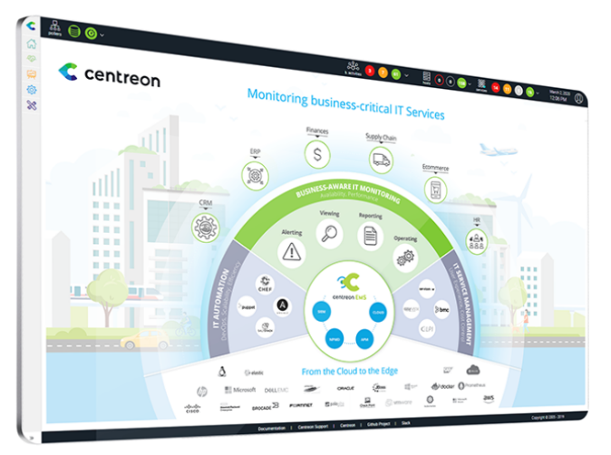

Toronto & Paris, September 17 2020 - Centreon, a trusted global provider of business-aware IT monitoring for always-on operations and performance excellence, has formalized a global partnership with EVA Group in Europe, North America, and Asia.
EVA Group is a leading player in IT and Cybersecurity consulting, specialized in three technology areas: Cloud & Infrastructure, Cybersecurity and Data. With 10 offices on 4 continents, EVA Group offers a real client proximity. The firm collaborates with major accounts and SMEs in many sectors - luxury goods, banking, industry, services, ministries - on their IT transformation projects: IS security, governance, as well as performance and innovation management.
EVA Group uses IT monitoring solutions to control IT infrastructure performance and service delivery. These solutions also provide performance indicators to the business and help detect incidents as quickly as possible to reduce business impacts. Today, Centreon Business Edition is integrated in some of the Operational Excellence Centers managed by EVA Group. The Centreon solution, based on an open source platform combines interfacing with any connected device with the possibility for customization. “We deliver value-added services for IT failure detection and anticipation, change management, as well as on-premise private/public cloud and SaaS infrastructure status reporting. Centreon enables us to provide our clients with customized, technically and/or business-oriented dashboards" explains Nicolas Grehier, CTO of EVA Group.

In North America, EVA Group offers Managed Services that integrate the Centreon software solution within a SaaS Monitoring platform. "For clients who invested in IT monitoring, the tools in place are often configured at only 25% of their capacity, not kept up to date, and not well mastered by the teams in charge. Thanks to EVA Group's expertise, our clients can monitor their entire IT workflow and react more quickly to incidents. The monitoring services offered aim to increase the 360° visibility of IT within a single platform and translate alerts into key insights on performance levels for the business" says Thomas Curutchet, Managing Director EVA Group Canada.
EVA Group is present in Asia with offices in Singapore and Hong Kong since 2013. "We offer managed services based on several tools including Centreon that enable our clients to gain visibility into the state of their infrastructure and capacity planning. We help them to improve their proactivity in incident detection, which is one of the major issues for many CTOs and technical managers" said Cyril Ayoub, Managing Director EVA Group APAC.
Marc-Antoine Hostier, Chief Sales Officer of Centreon concludes: "We are very pleased with this global partnership with EVA Group, whose expertise on Centreon's solution in international markets is recognized. The close relationship with EVA Group's teams enables our already productive collaboration to address Infrastructure & Operations issues for international clients operating in the utilities, insurance, luxury goods, transportation and education sectors.”

About Centreon
Centreon is a global provider of business-aware IT monitoring for always-on operations and performance excellence. The company’s holistic, AIOps-ready platform is designed for today’s complex, distributed hybrid cloud infrastructures. Privately held, Centreon was founded in 2005 as an open source software framework. Today, Centreon is trusted by organizations of all sizes across a wide range of public and private sectors. Centreon is headquartered in Paris and Toronto, with sales offices in Geneva, Luxembourg and Toulouse. For more information, visit centreon.com
Press Contacts
Marylene Durand – Centreon - mdurand@centreon.com - +33 6 16 90 43 40
Antoine Boulay – AB advisory – ab@abadvisory.fr – +33 6 25 16 13 29
Anne-Charlotte Dudicourt – AB Advisory – acd@abadvisory.fr – +33 6 47 90 28 30
About EVA Group
EVA Group is an IT and Cybersecurity Consulting firm, which assists major accounts and SMEs in the luxury goods, banking, industry and services sectors to address various challenges: support IT projects for transformation and innovation, identify and reduce cyber risks, design, build and operate efficient and secure information systems. Specialized in three technological areas - Cloud & Infrastructure, Cybersecurity and Data - EVA Group combines methodological know-how, high level of technical expertise, and R&D. EVA Group is established on 4 continents through 10 offices. Labeled HappyAtWork©, EVA Group is established on 4 continents. For more information: www.evagroup.fr
Press Contacts
Gabrielle GUERRINI - EVA Group - gabrielle.guerrini@evagroup.fr +33 6 68 94 49 70

